ASIAN PARLIAMENTARY ASSEMBLY

APA Standing Committee meeting
on Political Affairs

25 - 28 June 2019
Isfahan, Islamic Republic of Iran

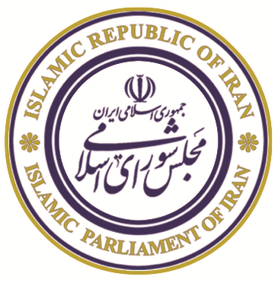 |  | 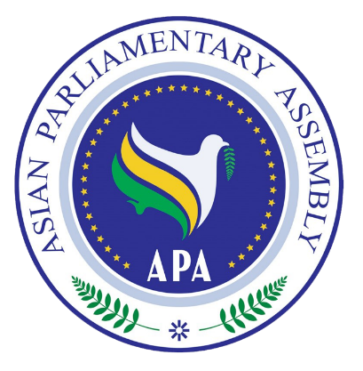

To facilitate our preparations to issue the identification badges, please complete
and return this form together with the Registration Form
List of Delegation of the country ……………….

No. | First Name | Last Name | Position | Photo

